Curriculum Vitae

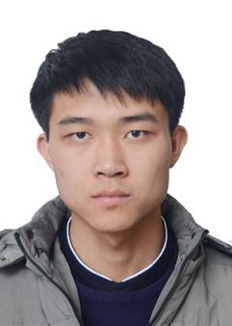

***Basic Information***

**Name:** Xinjian OUYANG

**Nationality:** Chinese

**Email:** xinjian.ouyang@student-cs.fr

***Educational Information***

* **Educational Background:**

2019.09-present General Engineering, *CentraleSupélec*, France

2017.09-2019.07 Mechanical Engineering, *Xi’an Jiaotong Universit*y, China

* **Language:**

Chinese: Native Language.

English: IELTS Band **7.5**/9.0.

French: Intermediate Level.

***Research Experience***

***Publications***

***Interests & Competences***

* Programming: C language, python, Matlab, Java and MySQL(DataBase).
* Digital Modeling: Auto CAD, SolidWorks, Inventor.
* Mastered the theory of Machine Learning and Statistics.
* Interests: Travelling, Reading and Physics.

***Activities & Awards***

* 2020.07-2020.08 Doing voluntary work in a charitable organization “*Août Secours Alimentaire”* in Paris for 4 weeks.
* 2019.07 “**Eiffel Excellence Scholarship**” program(2 years) of the French government
* 2019.10 the Second Prize in National 3D Innovative Design Competition
* 2018.10 “**National Scholarship**”awarded byThe Ministry of Education of P.R. China
* 2018.06 the Second Prize in the 2018 Mathematical Modeling Competition of XJTU